Name:
Date:
Block:

Four Key Historical Concepts – The Assignment
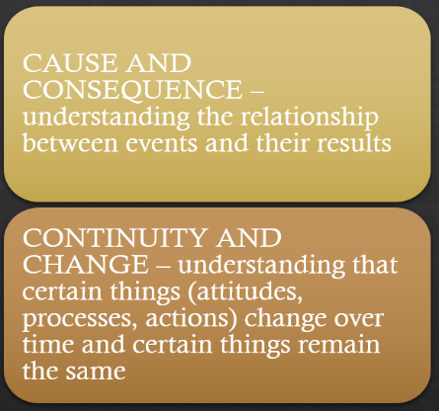
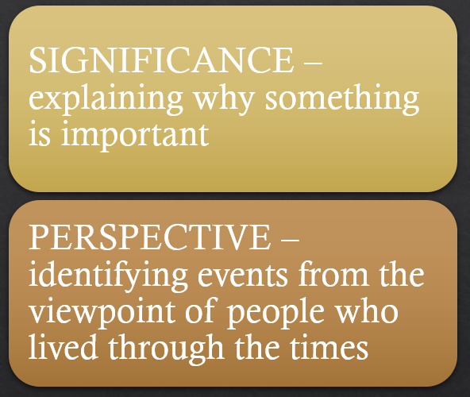

For this assignment you will be demonstrating your understanding of the four historical concepts we have been exploring in class: significance, cause and consequence, perspective, continuity and change.

- For each concept, choose an event from the list of Twelve Events that have Happened in Your Lifetime(the handout from class).
***You need to choose 4 different events.

- Complete the activities that follow. You need to explain and analyze each event through the lens of one of the concepts.

- Use the reference sheet on the four main historical thinking concepts to guide you.

***I’ve uploaded a copy of this assignment in Word on the class website if you would prefer to type it out. (Saves you a lot of formatting)

Due Date:__________________________________

Name :
Date :
Block

Historical Significance

Event

Brief description:

Criteria  (Include all that are relevant to the event) | Examples and explanation

Cause and Consequence

____ ________________
Event

Consequences
Causes

immediate
Long term
immediate
Long term

Historical Perspective
Event

Brief description:

Current Perspective: What are your views about what happened?

Perspective at the time: How would someone living through the moment have reacted to the event, and how would it be different from your own?

Context: Compared to what we face today, what relevant circumstances were different for them in the past? (Some examples might include social values, technology, media, economy, religion, family life, communication, recreation, etc.)

Continuity and Change
Event

Brief description:

- How did things stay the same?

- How did things change?

- Were the continuities and changes positive or negative?(explain)

- How rapid or slow were the changes?
(There may be some changes that are immediate, and some that were long term)

Sources

For this assignment, simply list your sources.
Include the title, author, and publication date

Title | Author | Publication date

Assessment – Comprehension/analysis and creating/communicating:

Beginning/Developing  Things to work on… | Applying  Standard to meet for this assignment | Extending  Things you did well…
Comprehension and Analysis

Can assess and gather information relevant to each of the four historical concepts.

Creating/Constructing and Communicating

Can express and support opinions with evidence.

Can communicate understanding using effective written communication.

Date:
Block:

Twelve Historic Events which Happened during your lifetime.

2009 - Inauguration of Barak Obama, the first African American to hold the office.
2009 - Minecraft created.

2010 - The first iPad.

2011 - Earthquake and tsunami in Japan which triggers the meltdown of the Fukushima Power Plant

2011 - World population reaches 1 billion.

2012 - The US rover, curiosity, takes a selfie on Mars, and finds evidence of an ancient streambed of water.

2014 - Malala Yousefzai is awarded the Nobel Peace Prize. - Malala was shot in the head shortly after she spoke about the right of girls and women to receive an education. The Taliban had taken over the region she lived in in Pakistan banned education for girls.

2015 - Canada’s Truth and Reconciliation Commission releases its final report on the legacy of residential schools, and recommendations for moving forward.

2015 - Racially diverse emojis are issued

2016 - Election of Donald Trump as US president.

2016 - Paris Accord – an international agreement on measures to tackle climate change.

2018 - The Royal wedding of Prince Harry and Meghan Markle.

