Current Events – Next Round

You have all survived the first round of presentations - well done. A great range of relative articles were brought in and discussed. Keep this up!!
For Round Two, you are going to do it all again. The assignment is still the same, but
To strengthen your presentation skills I want you to also:
- Use visuals – these can include a map, logo, photo, timeline, etc.
  - Refer to the visuals, point things out, ask questions about them – Use them in your presentation!!!
  - Visuals usually help your audience follow and understand your presentation – an effective tool

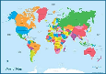
Talk about the visuals. Use them to help you explain.

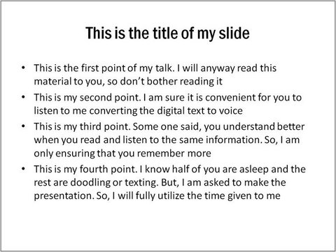
No, or very little, text on the slides.

This will help you avoid
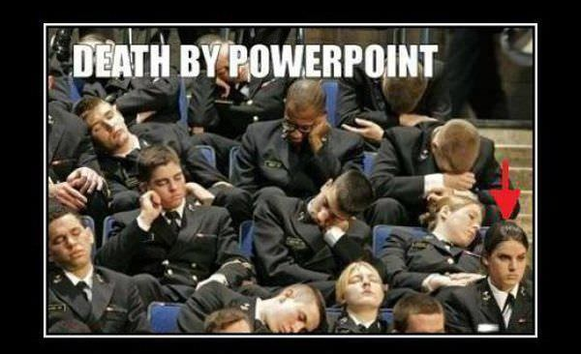

Put your images in a ppt and email me a copy before your presentation: zehn@vsb.bc.ca

- Plan out effective openings and conclusions for your presentation

Introductions – Use a hook to connect with the audience.
These should be brief, but interesting.

How to Start a Presentation and Engage your Audience

- Ask a question (this can be simple like “How many of you have eaten a hot dog?”)

- Use an interesting statistic or fact

- Tell a personal story

- Show a picture and ask something about it, or tell a story about it.

- Talk about the future, or the past.

This can be a very effective way to begin. Have a look at this introduction to a

presentation about nuclear weapons:

“It is August 29th, 1949. For most, life is moving along as usual. But what most people do not immediately realize is that the world would be a very different place from that day onwards. On August 29th, 1949, Communist Russia tested their first nuclear bomb. The world now had two nuclear Superpowers, and they hated each other.”

Conclusions – Summarize the main points and end with purpose.

Many are so relieved to get to the end of a presentation they say something like “and yeah” or “And that’s it”.

End with more of an impact!

What you are already doing - Offering your views and opinions at the end of the presentation is a good way to summarize and conclude.

You can:

- Refer back to the opening hook.
- Close with a summary
- Call to action
- Make it clear that you have finished. (even a simple statement like “Thank you.” works well.)

