Comparative Civilizations
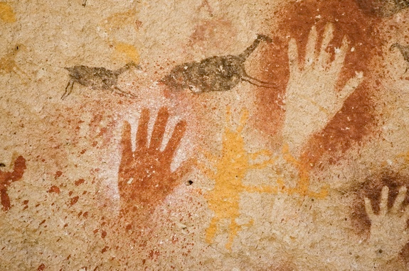
Course Outline
Ms. Ehn
(604)713-8220
zehn@vsb.bc.ca

Announcements, homework and resources are posted on the class website: socialszehn.weebly.com

Occasionally, we may be using Teams, especially if we find ourselves switching to a remote system. Fingers crossed that this does not happen, but be ready to pivot in case it does. If we are remote I will post what our plan for the day(s) is on Teams as well as the class website. If we are meeting remotely, it will be through Teams.

Overview

Welcome to Comparative Civilizations! This course investigates the history of humanity from the earliest times to roughly around the fifteenth century, give or take a few years. We will explore diverse societies from around the world, with particular regard to the political, cultural and economic structures and historical forces that shape the foundation of the modern world.

Topics:
These are the main topics we will aim to focus on. Depending on time, we may get to all of them, or focus on a few.

Human Origins - Emergence of Homo Sapiens, Paleolithic and Neolithic Life

Early Civilization - The River Civilizations(Mesopotamia, the Indus Valley, the Shang Dynasty, and the Maya)

Egypt – Overview of the lengthy history of Egypt. Focus on religious beliefs, art history and legacy.

The Greco-Roman World – the classical Greek world; the Late Roman
Republic and Roman Empire (Comparisons with China and other empires)

Mesoamerica – The Olmec, Maya, Aztec and Inca

Comparative Mythology – Mythic archetypes and global mythology

Independent Research - Self-Directed study - A chance to focus in on your
interests. You will develop your own topic and project.

Themes:

In addition to specific civilizations, we will also examine various themes such as:
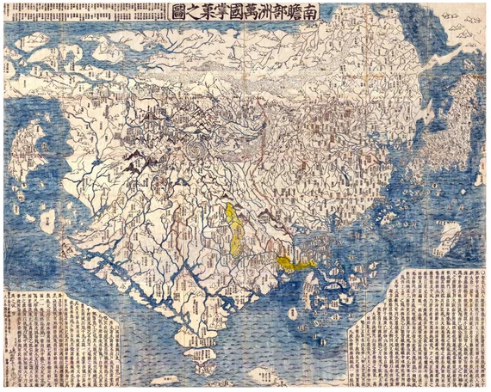
- mythology
- folklore and religion
- western vs eastern mindset
- art & architecture
- philosophy and ethics
- wealth/affluence and poverty/deprivation
- democracy and absolute power
- conformity and innovation
- spiritualism and materialism
- technology and nature
- individualism and collectivism
- ancient and contemporary thought

Curricular Competencies
Students are expected to be able to do the following

- Use Social Studies inquiry processes and skills to ask questions; gather, interpret, and analyze ideas; and communicate findings and decisions
- Assess and compare the significance of cultural expressions at particular times and places (significance)
- Evaluate inferences about the content, origins, purposes, context, reliability, and usefulness of multiple sources from the past and present (evidence)
- Analyze continuities and changes in diverse cultures at different times and places (continuity and change)
- Assess the development and impact of the thought, artistic expressions, power and authority, and technological adaptations of diverse cultures (cause and consequence)
- Explain different perspectives on past and present cultures (perspective)
- Make reasoned ethical judgments about actions in the past and present, and assess appropriate ways to remember and respond (ethical judgment)

Course Content:
The following is outlined in ministry’s Comparative Cultures 12 curriculum:

- definitions of culture and how these have changed over time
- elements of culture and cultural expressions
- conflict and conflict resolution within and between cultures
- systems of power, authority, and governance
- role of value systems and belief systems in the development of cultures
- interactions and exchanges between cultures
- interactions between cultures and the natural environment

Student Expectations:

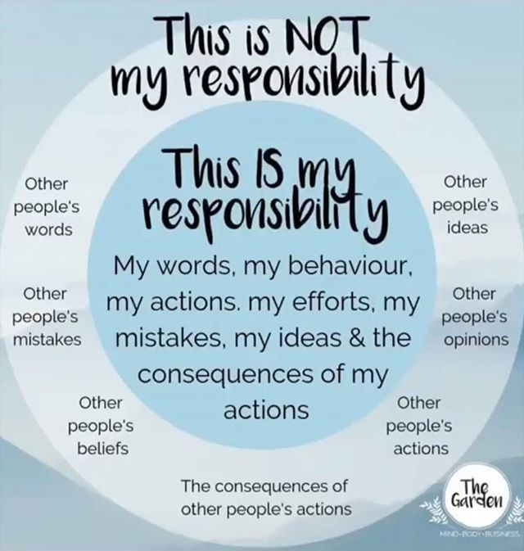

Involvement:
Get involved in the class. Contribute to discussions. Actively participate. You have chosen to be part of this group. You need to bring it!

Respect:
Show respect to your teacher and fellow classmates. This means, among other things, showing consideration when others are speaking, being reliable when working with others, and leaving the room in a decent state.

Responsibility:
- You will get out of this course what you put into it(kind of like life).

- Make sure you understand what is required of assignments.

- Be reliable, especially if when you working with others.

- Bring needed materials to class. Be on time.

- Check into Teams when you are in the remote sessions.

Evaluation

Term work 45%
(Includes homework and day to day assignments)

Tests and quizzes 25%

Final Research Project 20%
A chance to delve into a area you find intriguing. You will be developing
your own topic and project.

Seminars 10%
(Includes preparation, involvement, leading seminars,
and seminar reflection)

90+
78 89
65 77
50 64

