Comparative Cultures 12 – Class Seminars
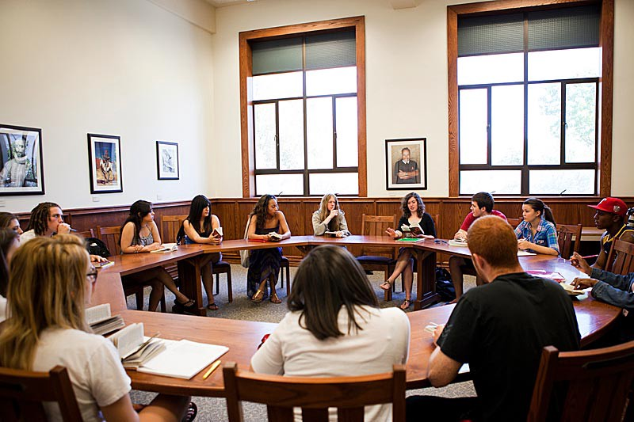
In this class, we will be holding seminar discussions to more deeply examine a text, idea or concept. You will be given opportunities to read and examine a common piece of text, which could range from articles to primary sources to literature.

During student led tutorials, a pair of students will conduct a seminar session. Each pair will present, ask questions, and lead the group in a discussion. The focus of the seminar will follow from the topic we are examining in class and is based on an assigned reading.

The Format

In a nutshell 1) Preparation – annotated reading
2) Seminar day - leaders and participants
3) Evaluation and reflection

I. Pre-Seminar Preparation

Once you receive the seminar text, allow yourself plenty of time to read, think, and annotate the text so you will be ready for the upcoming seminar.

Annotating a text – This term really means to write notes on the reading, any main points, connections, and questions you have.

You should circle, underline, or highlight the text and note, draw, or sketch in the margins of the text to record your preparation thinking. It will make it much, much easier for you to participate in the seminar.

There are many resources and guides for you on the seminar page of the class website.

Here are some question stems for you:

- What puzzles me is…  - I’d like to know more about…  - This is similar to what I know about…  - This is very different from…  - The big idea seems to be… | - I have questions about…  - One way to use this idea is to…  - Another point of view is…  - What if it meant…  - I have questions about…

Also look up the author.
Who are they? What is there area of expertise? Write down a bit of background on them. Do they have a certain political leaning which influences what they are saying?

If you are wondering what to do, have a look at the example provided.(“The Worst Mistake in the History of the Human Race” by Jared Diamond, 1999)

II. Seminar Day

On seminar days, the class will be split into three discussion groups. Each group will have two student leaders whose task it is to guide the discussion and keep it going. Towards the end of the seminar we will reconvene as a group and leaders of each section will summarize the main points discussed. After the seminar you will have a chance to reflect on the discussion and think about the main ideas and concepts which arose.

Leaders
During the seminar leaders will review the reading with the other participants.
The main role of the leaders is to help guide the discussion and keep the group on topic.

Outline of the responsibilities of the leaders:
i. Icebreaker question
ii. briefly review the reading with classmates
iii. discuss main questions and issues of the text
– create a set of 5-7 questions to discuss( I can help with this if you need ideas)
iv. ask questions and provide feedback)basically stimulate a discussion based on the readings)
-Encourage all to participate – prompt those who have not had a chance to jump into the conversation
iv. set up a speaker’s order when necessary(an queue when many want to speak)
vi. summarize to the class the main points and issues which arose

Participants
You are expected to come prepared.
As a participant, you are also expected to be fully involved and participate in the discussion.

****I will be joining each group during the course of the discussion to observe.

Guidelines for Seminar Leaders and Participants

- Refer to the text when needed during the discussion. A seminar is not a test of memory. You are not “memorizing the subject;” your goal is to understand the ideas, issues, and values reflected in the text.

- A successful seminar is one in which the members work together to help each other understand the reading and the questions that develop out of the readings and conversations. Talk about what you want to find out, not what you know.

- Help other participants build on other incomplete ideas.

- Come to class with questions, thoughts, or feelings about the text.

- Do not stay confused; ask for clarification. State incomplete thoughts, feelings, or questions. The seminar is about thinking out loud not about stating answers.
- Direct your thoughts, questions to the other participants, not to the teacher.

- Don’t raise hands; take turns speaking.

- Listen carefully.

- Speak up so that all can hear you.

- Discuss ideas rather than each other’s opinions.

- You are responsible for the seminar, even if you don’t know it or admit it - get involved and help the discussion go smoothly.

Expectations of Participants in a Seminar

When I am evaluating your Socratic Seminar participation, I ask the following questions about participants. Did they…

- Speak loudly and clearly?  - Use the text/documents to find support?  - Listen to others respectfully?  - Stick with the subject?  - Talk to each other, not the teacher?  - Paraphrase accurately?  - Ask for help to clear up confusion? | - Cite reasons and evidence for their statements?  - Support each other?  - Avoid hostile exchanges?  - Question others in a civil manner?  - Seem prepared?  - Encourage others who have not yet been heard?  - Take risks and dig for new meanings?

Easy (and Important) Ways to Become More Involved in a Seminar – Some Discussion Stems for you.

  - Ask a clarifying question.

“I’m not sure I fully understand what you’re saying. Can you restate what you just said?” What do you think the author means in line 6?”

  - Paraphrase another participant’s ideas for clear understanding.

“So what you’re saying is…”

  - Ask for specific illustrations.

“Can you give us an example to illustrate your point?”

  - Question the relevance of questions & comments.

“Could you explain how that question or comment relates to the current point?”

  - Search for possible alternate perspectives.

“Are there some ways to interpret this? Or Think about how someone from a different perspective might view this.”

  - Play the “devil’s advocate.”

  - Question assertions and underlying assumptions.

“Are we assuming that it’s true that…”

- Identify common ground to move the dialogue forward.

“Can we take it as a given that ________________ is true?”

- Ask for specific textual support.

- Identify connections to previous comments or questions.

“Does this relate back to the earlier idea about…?”

The Checklist(aka. So what exactly do I need to do and submit?)

Seminar Leaders:
- Annotate article(s)
- 5-7 discussion questions
- Lead the seminar
- Reflection

Seminar Participants:
- Annotate articles
- Participate fully in the discussion
- Reflection

