Name:
Date:
Block:

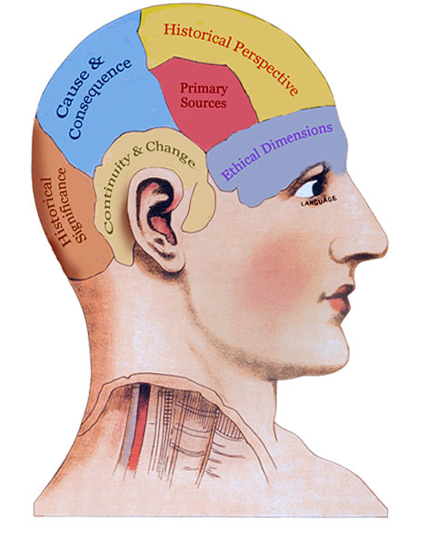
Four key historical concepts

Continuity and Change - How can we make sense of the complex flow of history?
- Continuity and change are interwoven – they exist together.
- Chronologies – timelines – are a good place to start. Organize the past into sections helps(eras, centuries, decades, dynasties, etc)
- Change is a process with varying paces and pattern.
- Turning points are moment when the process of change shifts direction or pace
- Change is not always constant, or predictable.

Historical Significance – How do we determine the importance of an event?
1. PEOPLE AT THE TIME THOUGHT IT WAS IMPORTANT
2. IT AFFECTED A LOT OF PEOPLE
3. IT AFFECTED PEOPLE DEEPLY
4. IT AFFECTED PEOPLE FOR A LONG TIME
5. IT STILL AFFECTS ATTITUDES OR BELIEFS TODAY
6. IT LED TO OTHER IMPORTANT EVENTS
7. IT HELPS US UNDERSTAND OUR WORLD AND OURSELVES
***Historical significance can change over time, and from group to group.

Cause and Consequence – Why do events happen, and what are their impacts?
- Change is driven by multiple causes.

- Historic events result in multiple consequences.

- Some causes are more influential than others.

Types of causes:
Immediate background long term
intentional unintentional major
minor natural accidental
long-lasting short-lasting

Historical Perspective – How can we better understand the people of the past?
- Consider your views about what happened (a current perspective)

- Examine how people at the time reacted to the event and how would it be different from your own.

- Avoid presentism – placing present ideas and values on events and people in the past.

- Consider the historical context of an event – what was happening at the time? What were the main beliefs and worldview of the time?

- Different groups and people from the past may have different perspectives and ideas on past events.

